**Date**: 6th April, 2022

**Abraca-data**

**Weekly Report**

**Tasks performed in this week**

* Implemented PCA for Dimensionality Reduction
* Further understood the PCA math.

----------------------------------------------------------------------------------------------------------------

**Outcomes of the tasks performed**

* The dimensionality was reduced to 2 from 15 input features, using PCA. This helps in faster computation and further modeling in a better way.

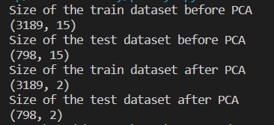

----------------------------------------------------------------------------------------------------------------

**Tasks to be performed in the upcoming week**

* We are planning to perform Exploratory Data Analysis on the dataset whose dimensionality has been reduced using PCA. Now, since it is a lower dimensional data, we can do the pair plot wise analysis.
* We are also planning to search for a better method for outlier handling.